Notes from the Association for Science Education Annual Conference at the University of Liverpool, 4-7 Jan, 2012.

Sue Howarth, Senior Lecturer, Science Education, University of Worcester.

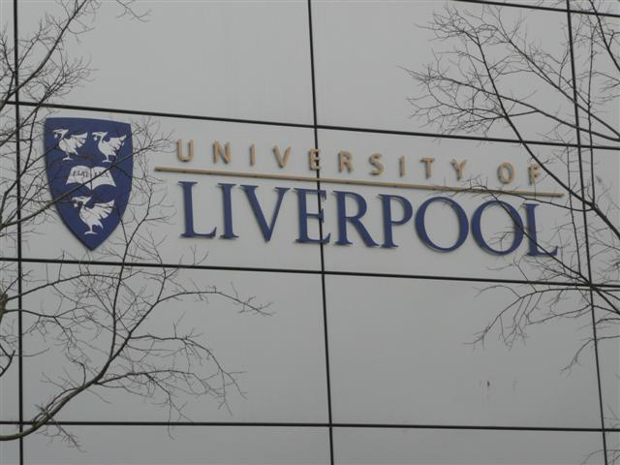
If you asked twenty delegates, attending this year’s ASE annual conference, to report what they had seen and done, all would likely produce a different account. This is my account. There was, as usual, much to choose between, and over the four days, many workshops, talks, presentations, lectures and other events took place in different venues around the University of Liverpool campus (Fig 1) and elsewhere. There were also ‘big’ names in Science education and the Olympics present including: Adam Hart-Davis, Steve Jones, Robin Millar, Steve Redgrave, Michael Reiss and Mike Tomlinson.

Arriving, Wednesday afternoon, somewhat buffeted by the walk up the hill from Lime Street station, I was keen to listen to a talk about the use of puppets in Science, a session in the Research seminar series (Fig 2).
Fig 1: One of the campus buildings, reflecting nearby trees

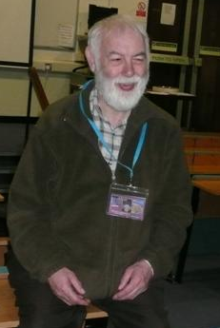
This session was memorable in that the presenter did not turn up, but a member of the audience entertained and informed us for half an hour on the use of puppets in Science learning and teaching, including details of a puppet project (www.puppetsproject.com.) This was a remarkable performance by Brenda Keough from Millgate House Educational Ltd, as she had not been expecting to do this. (Memo to self – buy/find/borrow puppet for primary Science education teaching next month.)

Fig 2. John Oversby, Mastermind of the Research seminar series

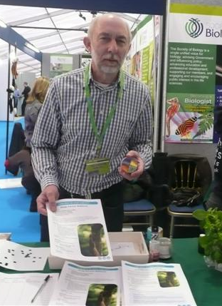
An exploratory walk around some of the exhibition stands provided lots of interest, including some new material from the Linnaean Society (Fig 3).

Fig 3 Dennis Taylor (of Green, Stout and Taylor Biology textbook fame), promoting new resources from the Linnaean Society, on a stand shared with the Society of Biology, the Association for the Study of Animal Behaviour, Kew Gardens and the Society for General Microscopy

The International Dinner on Wednesday evening, held in the Victoria Gallery and Museum (Fig 4) , next to the university campus included a perfect setting for a reception held for Science educators, who, glasses in hands, mingled amongst glass- fronted displays of rattlesnakes, sloths and – bizarrely – a definitive collection of tobacco pipes.
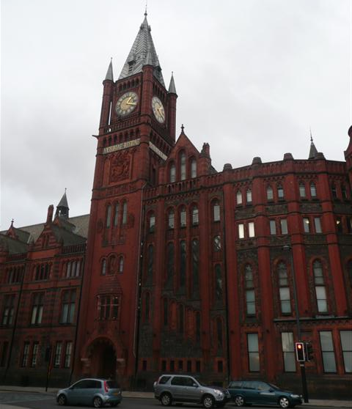
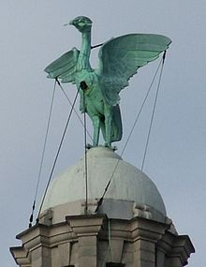
Noticing the ‘liver’ birds (Fig 5) on the museum beam ends encouraged a helpful local (who turned out to be the driver for the Lord Mayor) to explain about the legend of the cormorants with seaweed (laver) in their bills, hence the name laverpool, then Liverpool.

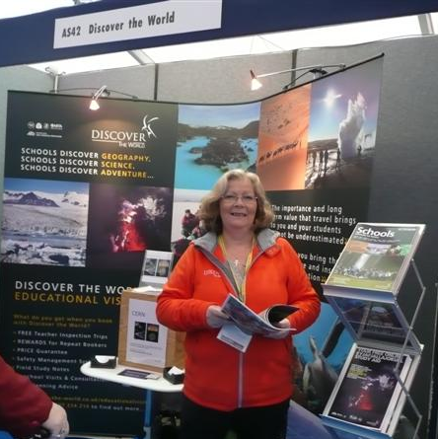
After a quick whizz round some more exhibitor’s stands early Thursday morning (Fig 6), a booked course ‘the STEM Challenge’ run by personnel from the national STEM Centre, proved less than the highlight of the day. Although I came away with a better idea of the national STEM library, the workshop itself was entirely Physics-based, not Science as advertised. Too much time trying out mostly familiar gadgets was not useful, though others were finding them fascinating. It did not help that the room was unfortunately too small for the number of participants.
Fig 5 One of the two Liver Birds, viewable from my 5th floor room in the Adelphi Hotel.
Fig 4
Victoria Gallery and Museum

Moving onto another booked course, this time as a helper rather than a ‘customer’, a couple of hours passed quickly as various people, keen to write for one of the ASE journals or write a book, came together under Valerie Wood-Robinson’s guidance about ‘Writing for the ASE’. Nice to say, at least one article has already arrived as a result of this workshop, first devised by Bob Kibble.

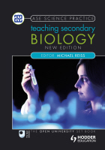
Publications Committee lunch was a smooth follow-on from the writing workshop with a chance to look at some of the latest books, such as ‘Teaching Secondary Biology’, 2nd edition (Fig 7).

Christine Harrison, from Institute of Education, London, gave a thought-provoking talk, another in the Research series, on assessment practices and perceptions of secondary Science trainee teachers, some of which has already been put to use in our programme at Worcester, since the conference.
Fig 6: Having been on a teacher tour to Iceland with Lorraine Silvester during the time of the Eyjafjallajokull volcano eruption, it was good to meet up again. Coming away with a sample of the volcano’s magnetic ash was a bonus.

‘Talking Science Education’, hosted by Michael Reiss, and with a distinguished panel including Mary Ratcliffe, gave delegates the chance to discuss assessment issues and what an ‘ideal’ scenario might look like. After lively discussion, it became clear that the majority of people present were not practising teachers in schools – a real pity as these are the very people who need to be heard in debates like this. Conversations with other colleagues also brought the relatively low numbers of UK school teachers present at the conference to light, with a suggestion that Easter or June/July might be a better time of year to hold the conference.
Fig 7. Teaching Secondary Biology, 2nd edition, ed: M.Reiss

Chairing a Frontier Science lecture is always a privilege, and Professor Mark Taylor’s talk on ‘Finding Nemo in a Nematode’ did not disappoint. With funding from the Bill and Melinda Gates foundation, Prof Taylor and his team at the Liverpool School of Tropical Medicine are tackling serious diseases, such as elephantiasis and river blindness, caused by nematode worms. These worms need symbiotic bacteria to function properly, and using antibiotics to kill the bacteria, rather than nematocides to kill the worms, is proving more effective in treating the disease. This was a fascinating link between theoretical research and a practical outcome, as well as another example of symbiosis to teach in class.

More time to visit the exhibitors, and gain useful information about the new hazard warning symbols (Fig 8) and the new resource on algae for schools from the SGM (Fig 9) was followed by another Frontier Science lecture.
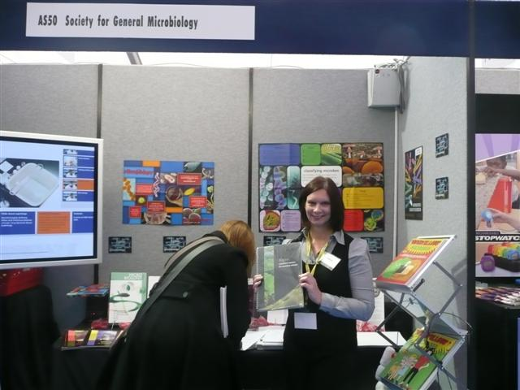
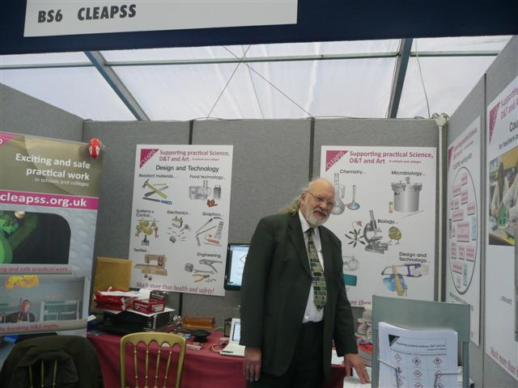

Fig 8 CLEAPPS and useful information about the new Hazard symbols
Fig 9 New resource
from SGM on algae

Professor Greg Whyte, who gave the lecture, has promised to write up his talk on ‘The Limits of Human Performance’ for the Olympic-themed issue of SSR in June.

A workshop, on Friday afternoon ‘Physics Made Fun’ did just that. The presenters were engaging, the materials were either simple (a bulb, a cell, and a piece of foil) or novel (a voice operated Frankenstein hand) and it really was fun and useful for future teaching. And I won an electronic rocket launcher.

A quick dash to catch some of the launch of the British Society for Microbiology’s launch of their new resource on using algae in schools was worth it. Not only a free copy of the resource (retailing at £20) and a great calendar but a drink, some nibbles and a chance to meet the Head of Education at Kew Gardens – who - small world - happens to be the mother of one of our current PGCE Science students.

Dinner at the Adelphi Hotel was a grand affair, using, what was once, so we were told, the ballroom for Hollywood stars and other notable guests before they set sail for America in the early 20th century. A wonderful mix on our table of Danish teacher trainers, a Chemistry teacher from Guernsey, a retired Head of Education at the Natural History Museum, London, and my esteemed colleagues, Roger Lock, ex-Birmingham, and Linda Scott, from Worcester.

Saturday morning allowed time to finish going round the exhibitors and to hand in my competition entry to Sigma Science (design an alien.)
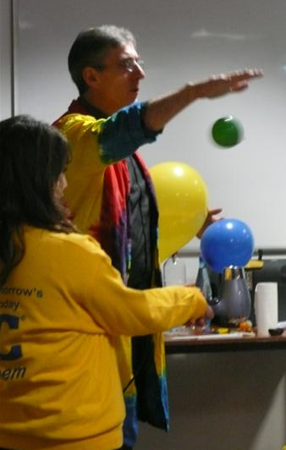
Another workshop ‘Inspiring Primary Science’ delivered ‘novel and fun ways to engage pupils’ as promised. Run by ‘Dr Mark’ there were a lot of good ideas, and his enthusiasm was catching.
Fig 10 Dr Mark and assistant (one of the conference helpers) having fun teaching about mass with a hairdryer and balloons.

Finally, it was time to give our research presentation on ‘improving retention in Science student teachers’ (P. Collins, L.Scott and S.Howarth.) The useful comments from the audience were much appreciated and are likely to help move our ideas forward. Our thanks go to John Oversby and the Research committee for organising these sessions.

Another research session, by Lynda Dunlop on Science in secondary education completed another great conference, not at all spoiled by the wet and windy (very) weather, though some exhibitors did wonder at one point if the giant marquee might take off.

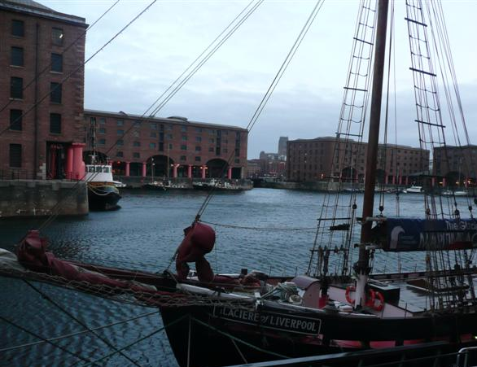
A brisk walk down to the docks (Fig 11), a hot chocolate in the Maritime Museum, a peep at the Museum of Slavery and a visit to the shop of the Tate Gallery was enough to convince me to visit Liverpool again soon.

And the conference? I’m already looking forward to next year’s at the University of Reading. And the competition? An email following the conference announced that I had won 1st prize - £100 for me and £100 for my university. I don’t really want to say what I did to win this. If you are really curious, the link below provides the answer.
And explains why I did not do art at school.
Fig 11 Albert Docks, Liverpool, late afternoon

http://www.sigmascience.co.uk/index.php?page=news&action=view_article&article_id=00007

